***Forest Park Swim Club Public Swim Lessons 2018***

Ages- 4-14 first half hour is non and beginning swimmers- 2nd half is children with some pool & swim experience- Children may be switched if needed and will be put in groups first day.

Sessions1,3,4 is 8 half hour classes- 1 instructor to no more than 6 swimmers .

COST: $55 each child per session for non-pool members. $45 for pool members- $5 sibling discount.

* Note class date changes for session 2- no class July 2&4- $40 non-members/35 pool members

Payment is due at first class. Cash or checks accepted-payable to Forest Park Swim Assoc.. Please do not bring payment to pool before first class or leave money in the mailbox!

For all sessions: 11:50-12:20 beginners 12:25- 12:55 intermediate & up

Session 1 – June 11,12,13,14,18,19,20,21 Mon- Thur both weeks(8)

Session 2* – June 25,26,27,28,July 3,5 Mon-Thur/ Tue,Thur(6)

Session 3 – July 9,10,11,12,16,17,18,19 Mon-Thur both weeks(8)

Session 4 - July 23, 24 ,25,26,31 Aug 1,2,3 Mon-Thur /Tue-Fri (8)

Please be at the pool 5 min early so your swimmer is ready- bring goggles too!

**PRIVATE LESSONS** are available for adults and children for $20 for 30 min. Times are flexible.

For information on private or public swim lessons please contact

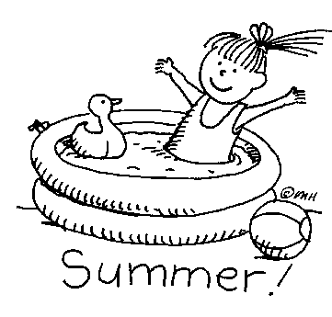 Sarah 925-202-8584

**Or email us forestparkswimlessons@gmail.com**

**You may email us or drop off this form at Forest Park in the swim lesson mailbox to reserve your spot! Do not bring payment before first class!**

_ _ _ _ _ _ _ _ _ _ _ _ _ _ _ _ _ _ _ _ _ _ _ _ _ _ _ _ _ _ _ _ _ _ _ _ _ _ _ _ _ _

Swimmer name & age________________________________________

Address_________________________________________________

Parent email ______________________________________________

Parent phone______________________________________________

Session & Time wanted_______________________________________

Please detach and leave in swim lesson mailbox or email information to [forestparkswimlessons@gmail.com](mailto:forestparkswimlessons@gmail.com)

Please do not bring any payment to pool before the first class!

1766 Mendocino Dr, Concord FORESTPARKPOOL. INFO Pool Phone 925-686-1333

Swim lesson info-call- 925-278-9988

 ***What are you doing this summer?***

Come Hang Out at Forest Park Swim Club!

Open Houses! Come Swim

April 22 & June 3 from 2-5pm

*Stop by and see our awesome swimming pool!*

Why join a swim club this summer?

- Your family can swim everyday school is out! We have a baby pool too! We are open weekends until school is out.

- We have a huge lawn area and BBQ’S! great place for summer gatherings and parties!

- We offer public swim lessons and swim team!

- Your kid will never be bored! There is always someone to hang out with! It’s a great place to meet new friends!

- NEW MEMBERS GET A DISCOUNT!!

- We are a member-run pool. Members all help out and this keeps our costs low!

**Many of your questions can be answered by checking out our website!**

**Forestparkpool.info**

**For more info about membership contact Nancy : 925-212-6485**

**We are located at 1766 Mendocino Dr in Concord across from Concord High School**

**Pool Phone : 686-1333**